1.When designing the user interface for an application, if it is unclear what skill level the end user of an application will possess, which of the following is the BEST approach to take?

A. Define the level of skill that will be required by the end user and make the necessary

B. arrangements for educating the users.

C. Define the level of skill that will be required by the end user and provide detailed on-line help that can be accessed by the users when needed.

D. Prototype portions of the user interface and perform some usability tests to identify any problem areas. Document any issues in the product readme and have the users read it before using the product.

2. Scheduling project activities such as functional increments and test case development, which one of the following OOAD artifacts is the MOST useful?

A. Class Diagrams

B. Interaction diagrams

C. Activity diagrams

D. Package diagrams

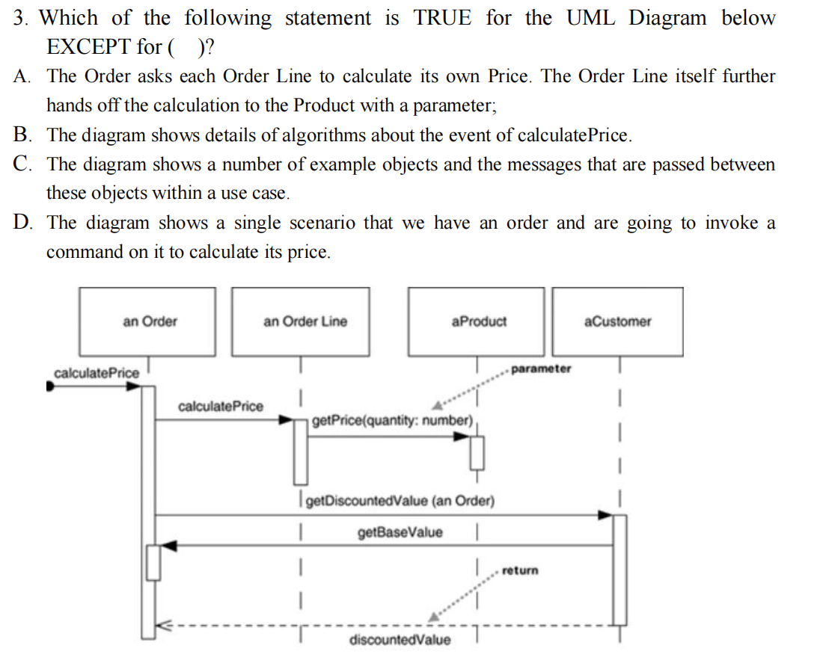

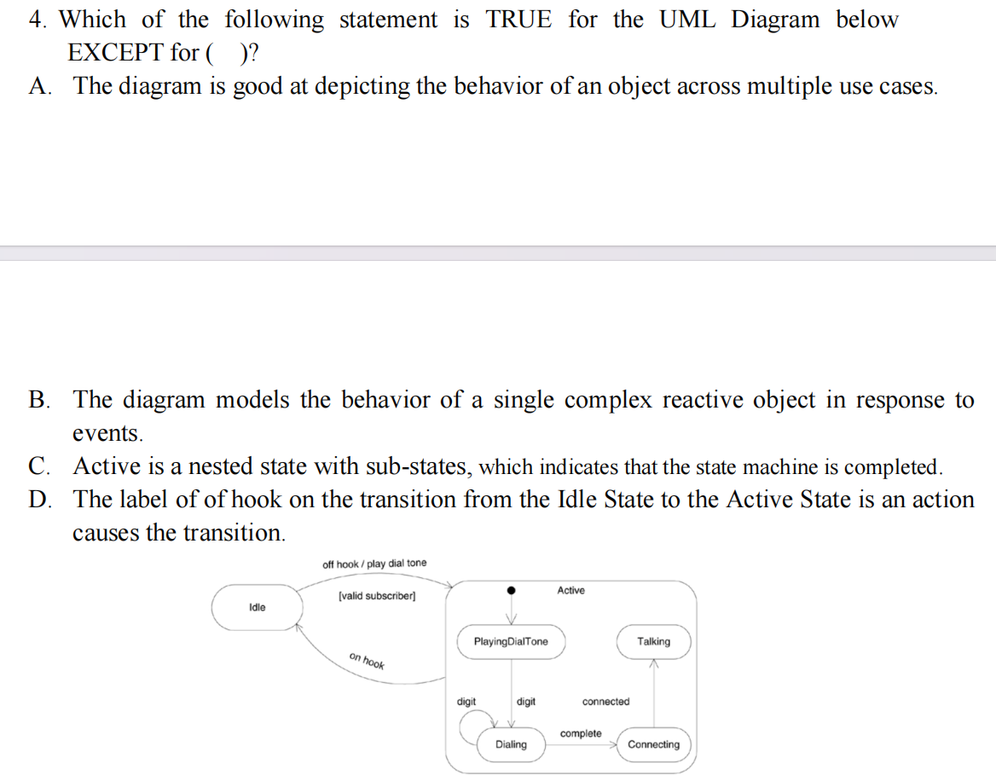

5. For showing how several objects collaborate in single use case, which one of the following OOAD artifacts is the MOST useful?

A. Interaction Diagrams

B. Activity Diagrams

C. Package Diagrams

D. State Diagrams

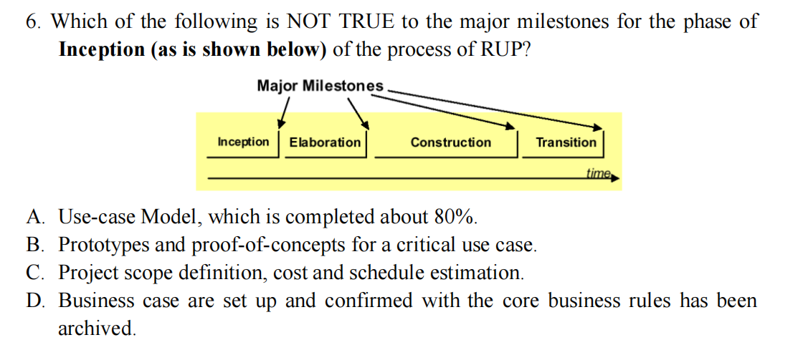

7. Which of the following statements are true? (Pick two)

A. Abstraction is when a client of a module does NOT need to know more than is in the interface.

B. Abstraction is when a client of a module does need to know more than is in the interface.

C. Encapsulation is when a client of a module is able to know more than is in the interface.

D. Encapsulation is when a client of a module is NOT able to know more than is in the interface.

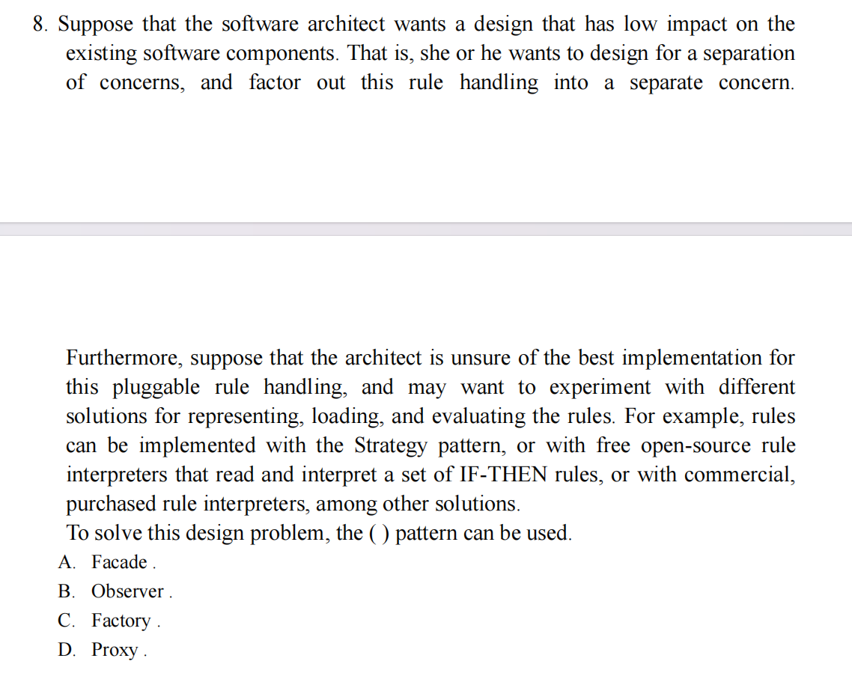

9. Which of the following statements are true about method visibility?

A: A class's methods are visible to all other objects of the same class independent of its visibility.

B: Other objects can access operations of a class if the visibility of the operation is public.

C: An object can access all of its methods regardless of the visibility of the operation's visibility.

D: A child class can access all of its parents operations regardless of visibility.

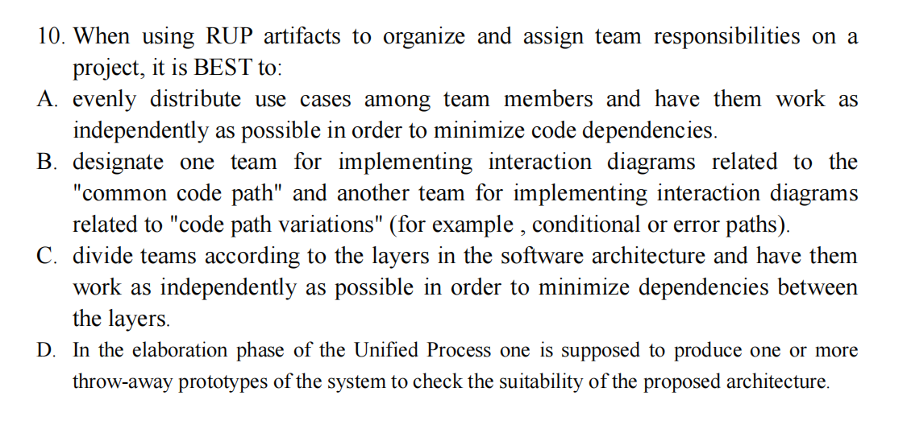

11. UML interfaces are used to

A. define an API for all classes.

B. program in Java, but not in C++ or Smalltalk.

C. define executable logic to reuse across classes.

D. specify required services for types of objects.

12. What is FALSE about Use Cases?

A. Use cases provide the basis of communication between sponsors and developers in planning phase

B. Use cases description provides a good source to identify domain concepts

C. A fully-dressed use case should include both “whats” and “hows” so that they are ready for “realization”

D. A use case is an interaction between a user and a system.

13. Which of the following statements are false? (Pick two)

A. If the Data Type of the feature is primitive (i.e., provided by the language, like int or strinG., model as an Attribute.

B. If the Data Type of the feature is near primitive (i.e., something like date or Money), model as an Attribute.

C. If the Data Type of the feature is near primitive (i.e., something like date or Money), model as an Association.

D. If the Data Type of the feature is user defined (i.e., a Class, or a pointer or a reference to a Class), model as an Attribute.

E. If the Data Type of the feature is user defined (i.e., a Class, or a pointer or a reference to a Class), model as an Association with an external entity.

14. Which of the following statement is true about the following sequence of activities ? (Single select)

1. Identify the use cases of system behavior.

2. Specify and refine each use case.

3. Define a scenario for each "interesting path" through the use case.

4. Draw an interaction diagram for each scenario.

5. Identify object models from object interactions in the interaction diagrams.

6. Define each state-based object's behavior with a state transition diagram using interaction diagrams for guidance. Typically, any events consumed or produced by the state transition diagram are mesages to and from that object in the interaction diagrams.

A. This describes the System Dynamics of Bottom-Up Design approach.

B. This describes the System Dynamics of Top-Down Design approach.

15. A car has four wheels. The class car and the class wheel have what type of relationship?

A: Association

B Aggregation

C: Inheritance

D: Realization

E: Dependency

16. Which of the following are NOT TRUE about the use case diagram? ( )

A. Use Case diagrams show the interactions between use cases and actors.

B. Use Case diagrams show which actors initiate use cases.

C. Use Case diagrams are used to show the flow of functionality through a use case.

D. Use Case diagrams illustrate that an actor receives information from a use case.

17. What is true about messages in scenarios? ( )

A. The operation of the calling object.

B. The operation of the called object.

C. It is sent by the actor to the system.

D. It is sent by the system to the actor.



Answer:

01-05 D C B C A

06-10 CD D A C C

11-15 D C BD B B

16-17 D B